**171. Analyzing Angular Observables:**

* In the attached project we can see that we have a subscription, listening to changing route params, 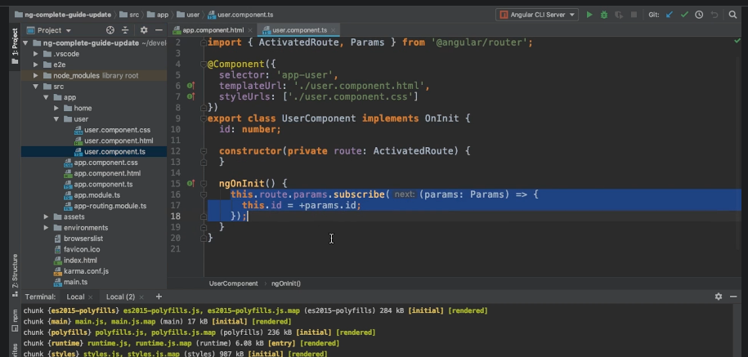
* so that if I am on the user page , on clicking user1 and user2, we can it updated

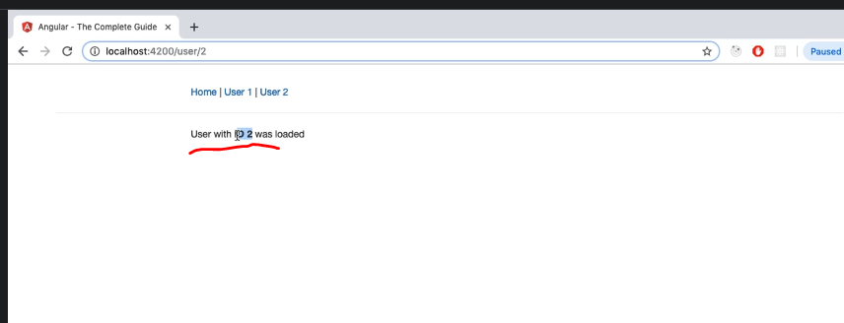

* So this functionality is using observable.

**How built in observable works:**

* Params is a observable to which we subscribe. Observable are constructs to which you subscribe, to be informed about changes in data. Params is a stream of route parameters . That stream gives us a new route parameter, whenever we go to a new page.
* Whenever the parameter in the URL changes, this is the function we passed to subscribe – we get the new params and we can extract our relevant param id from that .

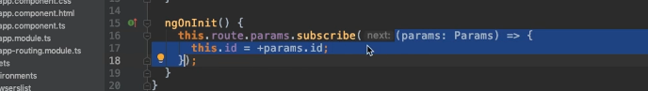

* Observables are stream of data – whenever an new data piece is emitted, our subscription will come to know about it .
* **Angular Observables:**
* We need not create it.
* We just need to subscribe to them